## COUNTERFEIT DRUG DETECTION USING NUCLEAR QUADRUPOLE RESONANCE

#### A Project Report submitted in partial fulfilment of the requirement for the award of the degree of

**BACHELOR OF TECHNOLOGY**

IN

**ELECTRONICS AND COMMUNICATION ENGINEERING**

**By**

#### CHITNEEDI TEJASWI SIVA RAM 16PA1A0419

**GUNJIANIL 16PA1A0444**

#### KADAMATI DIVYA LAKSHMI 16PA1A0458

**APPARI BHARATH KUMAR 16PA1A0406 GANDUBOYINA MAHESH DURGA VARA PRASAD 16PA1A0433**

Under the Esteemed Guidance of

**Dr. N. PADMAVATHY, Ph.D. (IIT- KGP)**

**Professor& Head**



**DEPARTMENT OF ELECTRONICS AND COMMUNICATION ENGINEERING**

**VISHNU INSTITUTE OF TECHNOLOGY (Autonomous)**

**(Accredited by NBA, NAAC, Approved by AICTE & Affiliated to JNTU Kakinada) Vishnupur, Bhimavaram - 534202.**

## 2019 - 2020

**VISHNU INSTITUTE OF TECHNOLOGY (AUTONOMOUS)**

#### (Accredited by NBA, NAAC,Approved by AICTE & Affiliated to JNTU Kakinada) Vishnupur, Bhimavaram-534202

**DEPARTMENT OF ELECTRONICS AND COMMUNICATION ENGINEERING**



### CERTIFICATE

This is to certify that the Project entitled **“Counterfeit Drug detection using Nuclear Quadrupole Resonance”** is being submitted by **CHITNEEDI TEJASWI SIVA RAM (16PA1A0419**), **GUNJI ANIL (16PA1A0444), KADAMATI DIVYA LAKSHMI (16PA1A0458), APPARI BHARATH KUMAR (16PA1A0406), GANDUBOYINA**

**MAHESH DURGA VARA PRASAD (16PA1A0433)** in partial fulfilment for the award of the degree of **Bachelor of Technology in Electronics and Communication Engineering** is a record of bonafide work carried out by them under my guidance and supervision during academic year 2019–2020 and it has been found worthy of acceptance according to the requirements of the university.

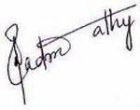

**Dr. N. Padmavathy Dr. N. Padmavathy,** Ph. D (IIT- KGP)

**Project Guide Professor & Head**

### External Examiner

### ACKNOWLEDGEMENT

Our most sincere and grateful acknowledgement is due to this sanctum, Vishnu Institute of Technology, for giving us opportunity to fulfil our aspirations and for successful completion of engineering.

We express our heartfelt thanks to our Principal and Director **Dr. D. Suryanarayana**

for providing us with the necessary facilities to carry out this project.

We express our deep sense of gratitude and sincere thanks to **Dr. N. Padmavathy**, our guide and Head of the Department (ECE) for her esteemed guidance and constant encouragement throughout the project. We are indebted for her instruction guidelines that proved to be very much helpful in completing our project successfully in time.

We also express our sincere thanks to **Project Review Committee Members**, Dr. A.

P. Ramesh, Mr. Ch. Rama Krishna and Mr. G. Prasanna Kumar for their valuable reviews and suggestions towards the completion of our project.

We express our thanks to all other **Teaching and Non-Teaching Staff** of the department and also to our **friends** for their good wishes and constructive criticism which led to the successful completion of our project.

We express our deep sense of gratitude and sincere thanks to our **Parents** for their good wishes and their encouragement throughout the project.

#### CHITNEEDI TEJASWI SIVA RAM 16PA1A0419

**GUNJI ANIL 16PA1A0444**

#### KADAMATI DIVYA LAKSHMI 16PA1A0458

**APPARI BHARATH KUMAR 16PA1A0406 GANDUBOYINA MAHESH DURGA VARA PRASAD 16PA1A0433**

### LIST OF ACRONYMS

ADC Analog- to- Digital Converter

AIDS Acquired Immune Deficiency Syndrome

ATR Attenuated Total Reflectance

CW Continuous Wave

EFG Electric Field Gradient

EL Electro Luminescent

ELSD Evaporative Light Scattering Diode

EMF Electromotive Force

EPR Electron Paramagnetic Resonance

FID Free Induction Decay

FM Frequency Modulation

FTIR Fourier Transform Infrared

HPLC High Performance Liquid Chromatography

IFPMA International Federation of Pharmaceutical Manufacturers & Associations

IR Infrared

LED Light Emitting diode

LMIC Low to Middle Income Countries

LNA Low Noise Amplifier

LPF Low Pass Filter

MATLAB Matrix Laboratory

NIR Near Infrared

NMR Nuclear magnetic Resonance

NQR Nuclear Quadrupole Resonance

RF Radio Frequency

SNR Signal- to- Noise Ratio

SQUID Superconducting Quantum Interference Device

TLC Thin Layer Chromatography

WHO World Health Organisation

### LIST OF NOTATIONS

*µ*m micrometer

nm nanometer

35Cl Chlorine

1H Hydrogen

13C Carbon

16O Oxygen

15N Nitrogen

115In Indium

Zn Zinc

Br Bromine

ZnBr2 Zinc Bromide

L Inductance

C capacitance

GHz Giga Hertz

MHz Mega Hertz

KHz Kilo Hertz

ps Pico seconds

***τ****p* Pulse duration

*ρ* Total magnitude,

*Kk* Scale factor for the amplitude of *kth* component of resonance signal

*βk* Attenuation coefficient

*ωk(T)* NQR resonance frequency,

*n(t)* noise component of FID signal.

*ŋk(T)* the echo signal damping factor.

*tg* the time interval between the first and second pulses

*Q* charge of the nucleus

γ/2π Gyro-magnetic moment

dB Decibels

H(p) Transfer function

Y(p) Laplace of NQR signal

X(p) Laplace of input signal

## LIST OF FIGURES

**Figure Name Page No**

Figure 1.1 Generic drug and Fake drug 2

Figure 1.2 Statistics regarding the Faking of medicines 6

Figure 1.3 Statistics of Pharma crimes involving faking of medicines 7

Figure 1.4 Statistics showing the increase in counterfeiting of drugs in various fields 8

Figure 2.1 High Performance Liquid Chromatography 12

Figure 2.2 Schematic of Fourier Transform Infrared Spectrometer 14

Figure 2.3 Raman Spectrometer 15

Figure 2.4 NMR Spectrometer 16

Figure 2.5 NIR spectrometer 17

Figure 2.6 Thin Layer Chromatography 18

Figure 2.7 Conceptual block diagram for NQR Spectrometer 19

Figure 3.1 CW NQR Spectrometer 27

Figure 3.2 Pulse Spectrometer 28

Figure 3.3 Br NQR transmissions in ZnBr2 29

Figure 4.1 High Frequency Transmitter 36

Figure 4.2 Receiver 38

Figure 4.3 Measuring Block 39

Figure 4.4 NQR frequency spectra for various chemicals 40

Figure 4.5 FID signal at the input of receiver for Indium 40

Figure 4.6 FID signal at the output of receiver for Indium 41

Figure 5.1 Transmitter output at spectrum analyzer without NQR subsystem 45

Figure 5.2 Receiver output for the 20 MHz signal without NQR subsystem 46

Figure 5.3 Transmitter output with NQR subsystem 47

Figure 5.4 Receiver output with the NQR subsystem 48

## LIST OF TABLES

### Table. No Page. No

**Table 1.1** Comparison between different fake drug detection methods 9

**Table 3.1** Selected quadrupolar nuclei 24

**Table 5.1** Input 43

**Table 5.2** Main Components 44

**Table 5.3** Outputs and their parameters 44

## ABSTRACT

Fake medicines are making their way into the market under the mask of genuine drugs. As per the studies of WHO, around 2,50,000 children are dying every year due to fake drugs. It is estimated that 20% of Indian drugs in the market are found to be counterfeit. India ranks at 154th place among 165 countries in terms of quality of life and accessibility of healthcare. Hence, there is a need to develop devices that can detect the counterfeits at a low cost, ease of handling and operability. There are several methods like Raman spectroscopy, HPLC, FTIR spectroscopy, X-ray diffraction and so on. Some of these methods are of high cost and involve complex procedures and sophisticated equipment.

The phenomena used by Nuclear Quadrupole Resonance spectroscopy include the interaction of Electric field gradient with the quadrupole moment of the nuclear charge distribution. Every element contains some isotopes which have non-symmetric charge distributed nucleus. When such nuclei are incident with RF signals, they absorb and re-emit the signals with some unique values for each element. Thus, when a sample is placed in an inductor coil coupled with a capacitor is induced with RF signals; it will generate a certain range of signals that are unique for each compound. This is also known as the chemical fingerprint. The values thus obtained will be very accurate and hence, performance can be more. The main drawbacks of this method are, it cannot be used on liquids, various interference comes into action like FM signals and thermal noise may also result in significant deviations. The drawbacks involving the interference can be overcome by using noise cancellation and isolation methods. The result can be checked via an indicator like LED or any other display so that we can understand if the given sample is genuine or not.

**Keywords**: Nuclear Quadrupole Resonance, Non-symmetric charge, RF signals, Electric Field Gradient, Inductor, Capacitor, Chemical fingerprint, Liquids, FM signals, Thermal noise, Noise cancellation, Indicators.

## CONTENTS

### Topic Page No

#### Title page i

Certificate ii

Acknowledgement iii

List of Acronyms iv

List of Notations v

List of Figures vi

List of tables vii

Abstract viii

Contents ix

1. INTRODUCTION 1-10
   1. Counterfeit Medicine 2
   2. Counterfeited Generic Medicine 3
   3. Health Risks 4
   4. Classifying Falsified Medicines 5
   5. Fake Medicine Statistics 5
   6. Therapeutic Areas with Counterfeiting Of Drugs 7
   7. Methods for Finding Counterfeit Drugs 8
   8. Overview 9
   9. Summary 10
2. LITERATURE SURVEY 11-22
   1. Previous Methods 12
      1. High Performance Liquid Chromatography (HLPC) 12
      2. Fourier Transform Infrared Spectroscopy (FTIR) 13
      3. Raman Spectroscopy 15
      4. NMR Spectroscopy 16
      5. Near Infrared Spectroscopy 17
      6. Thin Layer Chromatography 18
      7. NQR Spectroscopy 19
   2. Literature Survey 20
   3. Summary 21
3. NUCLEAR QUADRUPOLE RESONANCE 22-31
   1. History 23
   2. Instrumentation 25
      1. CW Spectrometers 25
      2. Pulsed Spectrometers 27
      3. Field Cycling NQR Spectrometers 29
      4. Some less Common NQR Detection Schemes 31
   3. Summary 31
4. MATLAB- SIMULINK DESIGN 32-41
   1. Introduction 33
   2. NQR Signal Model 34
   3. Imitating Model of NQR Pulsed Observation Method 35
      1. Transmitter 35
         1. NQR Subsystem 35
      2. Receiver 37
      3. Measuring Block 38
   4. Detection of Fake Drug 39
   5. Summary 41
5. SIMULATION RESULTS 42-49
   1. Summary 49
6. CONCLUSION 50-53
   1. Future Scope 51

REFERENCES **53-56**

**CHAPTER I**

**INTRODUCTION**

## INTRODUCTION

Counterfeit medicines are a huge backlashes to the health of the public both developing and developed countries. Counterfeit medicines might be prevalent in various sectors such as private and government hospitals along with countless number of distributors. Licensed pharmacists, health care provider, distributors and patients cannot find the difference between the original and a fake medicine.

It is very difficult to estimate the vastness of the problem of fake/counterfeit medicines in such sectors because of the lack of skills and resources to find fake medicines, the different meanings of counterfeit medicines in different countries worldwide, the absence medicines regulatory systems as well as the variations in the distribution systems.

### COUNTERFEIT MEDICINE

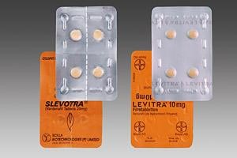

**Figure 1.1** Generic drug and Fake drug

The International Federation of Pharmaceutical Manufacturers & Associations (IFPMA) and the World Health Organization (WHO) describe counterfeits as drugs that are illegally labelled with respect to their origin and/or identity to fool consumers [1]. Simply, counterfeits are drugs that do not come from, or are not offered in the same form as, medicines from the original manufacturer. The Figure 1.1 shows two drugs which are similar to a common man, but one is a fake one and the other is a real one. Without proper tests, it is impossible to diagnose these two drugs. Excluded from this are changes that have been appropriately and legitimately made, as on account of equal imports. Fakes extend from complete fakes that have been made by a forger, to unique items with controlled termination dates. Instances of falsified drugs are meds that-

* + - contain the right dynamic agent, in any case, either at a measurements that is excessively high or excessively low,
    - have controlled lapse dates,
    - possess no dynamic agent,
    - contain a functioning agent other than the one indicated, or
    - Are enveloped by manufactured bundling, rankles or potentially contain misrepresented patient data.

Lamentably, patients, specialists or drug specialists will be unable to recognize such meds from the genuine ones without a point by point review. In the event that buyers are dubious, they should contact their PCP, drug specialist or the first maker. This influences licensed drugs just as generics. Costly doctor prescribed medications, for example, those utilized in AIDS or malignant growth treatment, are particularly rewarding for questionable organizations. Anti-infection agents are the most usually forged medications, especially in low-salary countries where drugs are restrictively costly for some individuals. In high-salary nations, there is a developing pattern toward counterfeit "way of life" meds for treating erectile brokenness. Hypothetically, every patient is in danger, despite the fact that there may be contrasts at the national level. Patients ought to be wary about purchasing drugs on the web, or when buying prescriptions abroad.

### Counterfeited Generic Medicine

Valid generics are believable meds. Nonetheless, criminal associations progressively offer items that are probably comparable to certain unique conventional items, or to their dynamic fixings. To forestall mistaken assumptions: "generics" are legitimate meds created after the first (brand-name) item has lost its patent insurance. Generics are accessible under an alternate name, yet offer proportionate quality to mark name items. Generics producers can likewise be survivors of forgers. Here, as well, the most significant standard is: physician endorsed medications may not be circulated without a medicine. Any individual or organization who offers physician endorsed prescriptions, and cases these are like a unique item is potentially offering counterfeit medications.

### Health Risks

Prescriptions are utilized to treat infections and to advance well-being. That isn't imperative to forgers. They are not keen on furnishing patients with a medication that is proportionate to the first item. Regardless of whether a phony medication contains certain dynamic fixings, these meds have a lower quality or amount of the substance. This can cause an immunization or test result to fizzle, for instance, or can even prompt pathogens getting impervious to the first dynamic substance. Law makers have built up an intricate technique to clinically inspect, favor, and follow-up prescriptions which is as it should be.

In remarkable cases, falsifiers incorporate dangerous or even toxic substances to their things to achieve a comparative effect (even more accurately, a response, not a certified therapeutic property) as saw with the primary drug to re-order realness. Finally, patients need reliable, direct information about the sign, use and estimation of their remedies. This is the explanation arrangements are required – to shield patients from broad dangers and potential damages of a prescription. The supporting specialist as well as medication masters explains the application, the correct estimation and possible manifestations of the drug to the patient. Any person who gives doctor embraced medication without a medication evades this secured gathering for the patient. The problem on a Global Scale unlawful trade happens everywhere throughout the world. The World Health Organization (WHO) measures that phony medications worth 73 billion Euros are traded each year. Flawed online medication stores thatconceal their genuine territory pass on all around – showing up at countries, for instance, Germany, UK, Italy, Spain, etc or the USA. Supplies from unlawful web sedate stores – those without legitimate certification – are up to 50 percent fakes. The level of the issue vacillates remarkably among regions and individual countries, and moreover depends, all things considered, upon fleeting supplies. The issue is outstandingly dependent on how close genuine controls are.

The WHO measures that in specific locales in Africa, Asia, and South America; more than 30 percent of solutions accessible for use are fakes. In specific countries of Eastern Europe, the degree of fake meds can be more than 20 percent. In Europe and in the USA, similarly as in other made countries, shy of what one percent of the medications sold are fakes. In spite of this, the pattern shows that fakes in our

globalized world are not, at this point only an issue of creating nations. When voyaging, patients frequently buy their drugs abroad (and at times, bring them home for relatives and companions, despite the fact that it is denied to do as such). Common market structures and exchanging courses have been changed; permitting merchants to sell prescriptions at lower costs and to wrap things up, the web has made deals and exchange of different articles less difficult and progressively worldwide.

### Classifying Falsified Medicines

One approach to arrange misrepresented medications is to allot classes dependent on the complexity of the phony. This is a case of such arrangement [2].

* Category 1: Completely fake items with obscure substance and helpful impacts essentially unique in relation to the real medication.
* Category 2: Look to some degree like the medication being imitated, yet the medication structure isn't known.
* Category 3: Look fundamentally the same as or indistinguishable from the certified item yet contain a totally extraordinary medication, assuming any.
* Category 4: Look fundamentally the same as or indistinguishable from the genuine item however contain an elective medication or engineered simple giving comparable remedial incentive to that of the bona fide item; proposed to make rehash business.
* Category 5: Visually indistinguishable, profoundly advanced duplicates or engineered analogs with some helpful worth that can't be identified utilizing most field and lab strategies.

### FAKE MEDICINE STATISTICS

It is estimated that about 25% of India‘s medicines are fake. Fake medicines are prevalent in all types of medical categories. Medicines play a crucial role in patient‘s health recovery and even a small increase in the dosage may become fatal to his/ her life. The dosage given need to be very exact and appropriate, but with the intake of fake medicines the life of the patient may be in grave jeopardy. Doctors cannot do anything if any side effects occur due to fake drug intake as there will be in a hind sight of the chemical composition of the drug

which was taken by the victim. Cardio means heart related, cytostatic involve medicines that cure or help in curing the cancer.

The statistics of increase in fake medicines in a chronological manner is given in the Figure 1.2 mentioned below. Blue dotted line in statistics indicates total number of alerts. Green dotted line in statistics indicates number of falsified alerts. Red line in statistics indicates number of medicines involved. Yellow coloured line indicates total number of number of original medicines involved. The cases are significantly increasing day by day and even governments cannot give a correct analysis regarding the fake medicines.

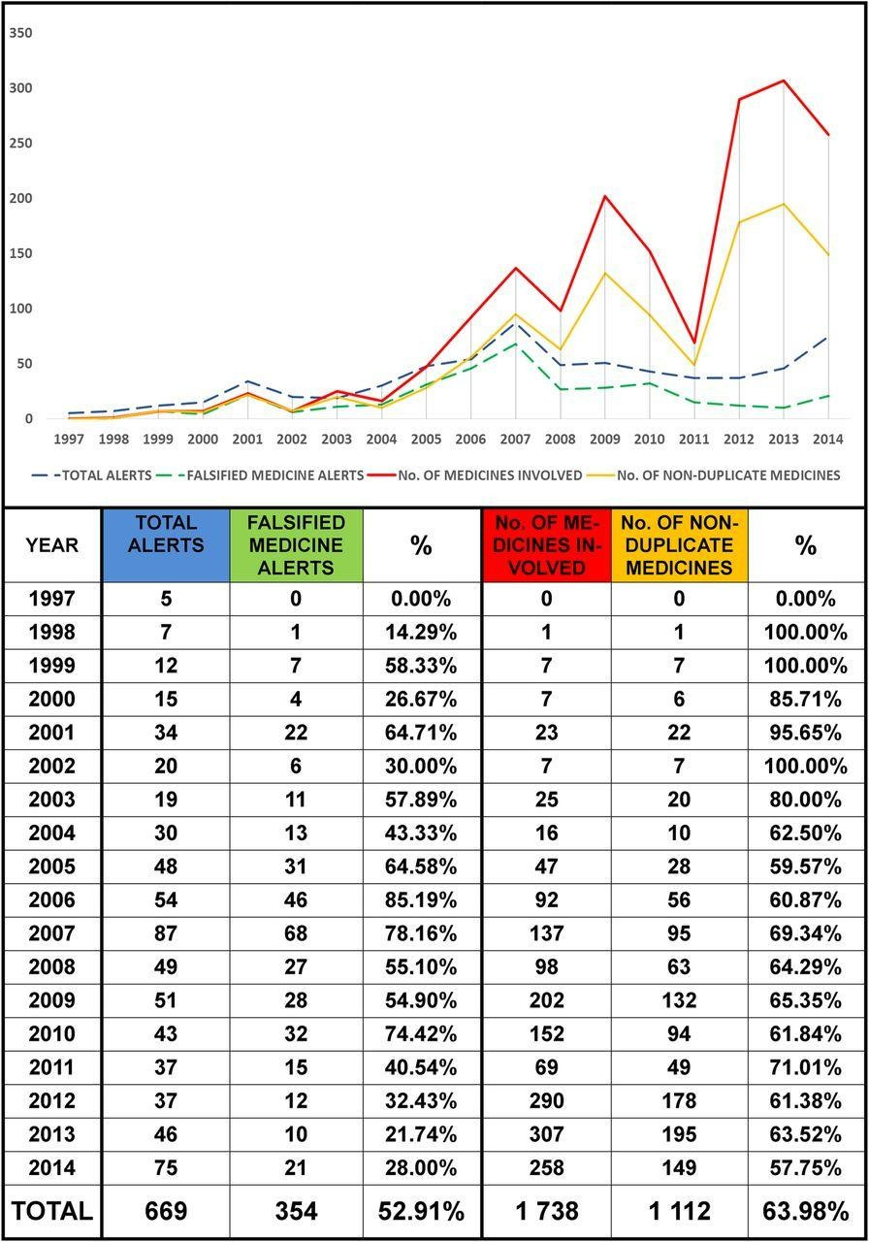

**Figure 1.2**Statistics regarding the Faking of medicines.

We can clearly understand from the Figure 1.2, that the fake medicines are increasing every year even though stringent laws are being implemented. Mafias formed and many criminal activities are undergoing in medical fields. The crime statistics are shown in the Figure 1.3 and these are continent based. Asia got huge problems with black markets in almost all sectors. It is the main reason that Asia has high cases occurred regarding pharma crimes. The crimes may seem to be small in number, but each crime may have corrupted thousands of tons of medicines.

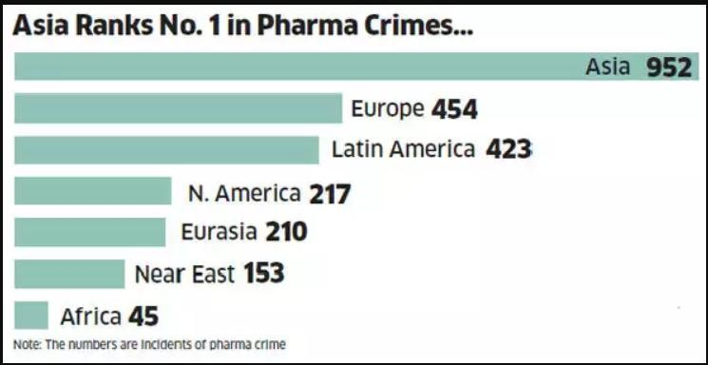

**Figure 1.3** Statistics of Pharma crimes involving faking of medicines.

### THERAPEUTIC AREAS WITH COUNTERFEITING OF DRUGS

There are several fields in medicine and the main or the fields with most demand for medicines are Respiratory, Musculo- skeletal, Nervous system, Cardio, Diabetes, and Hormones. These areas are more affected by counterfeiting because as mentioned before, the need for these medicines is high, hence people will surely buy medicines for their survival. Illiterate and poor people cannot find the difference between a fake drug and generic drug. Thus, crooked dealers will take advantage of their innocence. The increase in counterfeiting in the above mentioned areas is shown in the Figure 1.4. The Figures explain that the counterfeiting has been increased in the respective areas. Of all the fields the medicines

related to hormones are counterfeited most because there are many people who suffer with hormonal imbalances likediabetes, thyroid problems, pituitary, and fertility.

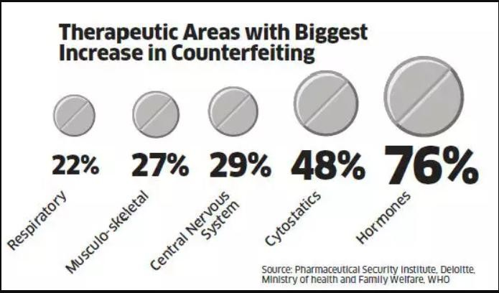

**Figure 1.4** Statistics showing the increase in counterfeiting of drugs in various fields.

### METHODS FOR FINDING COUNTERFEIT DRUGS

There are numerous techniques to discover fake medications. Advancements for recognizing unacceptable and adulterated medications were distinguished principally through writing audits. Key-witness interviews with specialists increased our strategies when justified. So as to help correlations, innovations were relegated a reasonableness score for use in LMIC (low to medium income countries) going from 0–8.

Scores estimated the requirement for power, requirement for test planning, requirement for reagents, versatility, level of preparing required, and speed of examination. Innovations with higher scores were esteemed the most attainable in LMICs [3]. The innovations that cost $10,000 USD or less as minimal effort, $10,000–100,000 USD as medium expense and those more noteworthy than $100,000 USD as significant expense advances (all costs are 2013 USD). This inquiry methodology yielded data on 42 extraordinary advancements. Five advancements were esteemed both minimal effort and had plausibility scores between the range 6–8 (Table 1.1), and an extra four innovations had medium expense and high achievability [4].

Numerous advancements can help in the recognition of unacceptable and adulterated medications that shift from the least difficult of agendas for bundling to the most mind boggling mass spectroscopy investigations. Despite the fact that there is no single innovation that can serve all the prerequisites of distinguishing misrepresented and unacceptable medications, there is a chance to bifurcate the advances into explicit specialties to address explicit segments inside the work process procedure of identifying items.

Some popular technologies are: 1. High Performance Liquid Chromatography (**HLPC**).

1. Fourier Transform Infrared Spectroscopy (**FTIR**).
2. Near Infrared Spectroscopy.
3. NMR Spectroscopy.
4. Raman Spectroscopy.
5. Counterfeit devices #3 [5].
6. NQR Spectroscopy etc.

The above mentioned methods are clearly explained in the next chapter 2 i.e. Literature survey.

### Overview

Each method above stated has its own advantage and disadvantage. Some methods are costly and involve highly trained technicians and sophisticated equipment. Whereas some are cheap but are inaccurate by nature. Table 1.1 shows the scores given to each method.

**Table 1.1** Comparison between different fake drug detection methods

|  |  |  |
| --- | --- | --- |
| TECHNOLOGY | COST | SCORE |
| HLPC | Rs. 25,00,000 | 1 |
| FTIR | Rs. 7,00,000-Rs. 10,00,000 | 8 |
| Near Infrared Spectroscopy | Rs. 10,00,000-Rs. 30,00,000 | 7 |
| NMR Spectroscopy | Rs. 7,00,000-Rs. 70,00,000 | 0 |
| Raman Spectroscopy | Rs.5,00,000-Rs.25,00,000 | 7 |
| Counterfeit devices #3 | Rs.15,00,000 | 6 |
| NQR Spectroscopy | <Rs. 1,00,000 | 4 and can be improved |

Even though the scores from the Table 1.1 are satisfactory for many methods, they can only be implemented under the supervision of highly trained technicians and some of them even require staff and buildings. It is impossible for a layman to find whether the drug bought is real or not by using such complex technology. Hence, by the thorough studies and considering the situation of several people of poor and under-developed countries, further improvement to develop the NQR spectroscopy can help in achieving a counterfeit drug free society.

In this project, a simulink model of an NQR spectrometer is designed. The model consists of a transmitter, a receiver and a measuring unit. The NQR signals are mathematically modelled and simulated to mimic the Field Induction Decay (FID) pattern of NQR signal and determine if the medicine is fake or real.

### SUMMARY

This chapter briefly introduces the concepts of various methods for fake drug detection and a qualitative and quantitative comparison between them, gives the idea of NQR spectroscopy in finding counterfeit drugs. Literature survey of previous methods is being discussed in detail in the next chapter 2 .i.e. Literature survey.

**CHAPTER II**

# LITERATURE SURVEY

## LITERATURE SURVEY

In relevance to the concepts of counterfeit drugs and the detection of them, an elaborate study on the existing approaches for the fake drug detection has been conducted. The forthcoming sections describe the previous methods namely, High Performance Liquid Chromatography, Fourier Transform Infrared spectroscopy, RAMAN spectroscopy, Nuclear Magnetic Resonance spectroscopy, Near Infrared spectroscopy etc in detail.

### PREVIOUS METHODS

### HIGH PERFORMANCE LIQUID CHROMATOGRAPHY (HLPC)

High Performance Liquid Chromatography (HPLC)[6] is a type of column chromatography that pumps an analyte in a solvent which is also known as the mobile phase, at high pressure through a column with chromatographic packing material (stationary phase). The sample is moved by a moving carrier gas stream of nitrogen or helium. HPLC has the capability to separate, and identify compounds that are consisted in any sample that can be dissolved in a liquid in minute concentrations as small as parts per trillion. Because of this flexible nature, HPLC is used in many industrial and scientific applications, such as, environmental, chemicals, forensics, pharmaceutical, .

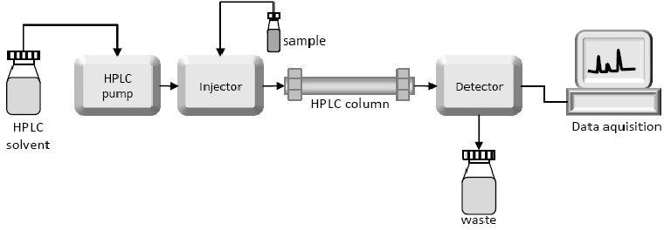

**Figure 2.1** High Performance Liquid Chromatography.

The Figure 2.1 shows the basic blocks in HLPC method for the detection of fake drugs. The important parts in an HPLC system are the solvent reservoirs, multiple reservoirs, a high-pressure pump, a column, injector system and a detector.

The reservoir contains the solvent, which is called as the mobile phase because it is mobile. There are at least two reservoirs in a system, with each holding up to 1000 cc of solvent and fitted with a gas diffuser through which helium or nitrogen can be bubbled. A pump is used to create a specified stream of the mobile phase. Although manual injection of samples is possible, most HPLCs are fully automated and computer controlled. The injector introduces the solvent into a phase stream that carries the sample into the high pressure (up to 400 bars) column, which consists of specific packing material needed to induce separation. The packing material is called as the stationary phase because it is fixed at a place by the column hardware.

A detector is essential to see the segregated compound bands as they elute from the high pressure column. The data is sent from the detector to a computer which creates the chromatogram. The mobile phase comes out from the detector and is either sent as waste, or preserved. The compounds are measured and checked carefully to find if any illicit compounds are contained in the medicine.

### FOURIER TRANSFORM INFRARED SPECTROSCOPY (FTIR)

Fourier Transform-Infrared Spectroscopy (FTIR) [7][8] is an effective technique used to find organic and inorganic materials. This technique calibrates the absorption of infrared radiation by the sample material along with the wavelength. The infrared absorption bands find out the molecular components, compounds and structures.

When a material is incident upon with infrared radiation, excites molecules into a higher vibrational state. The wavelength of light absorbed by a molecule is a function of the energy difference between the steady and excited vibrational states. The wavelengths which are absorbed by the samples are characteristic of their molecular structures.

The FTIR spectrometer uses an interferometer to adjust the wavelength from a broadband infrared source. A detector calibrates the intensity of transmitted or reflected light as a function of its wavelength. The signal obtained from the detector is an interferogram, which isanalyzed with a computer using Fourier transforms to obtain a single-beam infrared spectrum. The FTIR spectra are usually obtained as plots of intensity versus wave number (in cm-1). Wave number is the reciprocal of the wavelength. The intensity can be plotted as the

percentage of light transmitted or absorbed at each wave number. The Figure 2.2 shows a typical FTIR spectrometer.

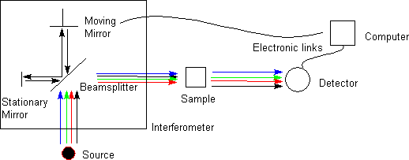

**Figure 2.2** Schematic ofFourier Transform Infrared Spectrometer.

**Qualitative Material Identification** - To check and find the material being analysed, the unknown IR absorption spectrum is equated with standard spectra in computer databases or with a spectrum from a known ideal material. Spectrum matches finds the polymer or other materials in the sample. Absorption bands in the range of 4000 - 1500 wave numbers are typically due to functional groups. The region from 1500 - 400 wave numbers is called as the fingerprint region. Absorption bands in this region are usually due to intra- molecular phenomena and are highly unique to each material.

**Quantisation** - Quantitative concentration of a compound can be found from the area under the curve in characteristic regions of the IR spectrum. Concentration calibration is obtained by setting up a standard curve from the spectra for identified concentrations.

Sample requirements vary depending on the sample structure and device. Samples may be in solid, liquid or gaseous forms. When the spectrometer is equipped upon with a microscope, the analysis area can be as tiny as 10 µm. Thin Organic films on a reflective surface like gold can be analysed in- situ using the microscope's reflectance mode. The outer 1-10 *µ*m of a material can be studied using attenuated total reflectance (ATR).

### RAMAN SPECTROSCOPY

Raman Spectroscopy is a non-destructive chemical analysis technique which gives elaborated information about chemical structure, crystallinity, polymorphy, phase, and molecular interactions [9]. It is based upon the reaction of lightwith the chemical bonds within a material or sample [10].

Raman is a light scattering technique, where a sample scatters the light incident on it from a high powered laser light source. Most of the scattered light is of same wavelength as the laser source and does not give useful information – this is called Rayleigh Scatter. However a small amount of light (typically 0.0000001%) is scattered at different wavelengths, which depend on the chemical structure of the analyte – this is called Raman Scatter [11]. Based on the amount of the scatter the compounds present in the material. The Figure 2.3 shows the schematic of Raman spectrometer. The laser used in the Raman spectroscopy itself costs around Rs. 2, 00,000- 7, 00,000.

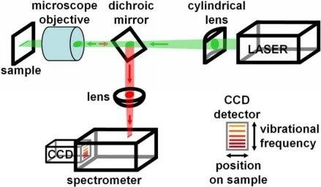

**Figure 2.3** Raman Spectrometer.

### NMR SPECTROSCOPY

NMR is an acronym for Nuclear Magnetic Resonance [12]. An NMR instrument finds the molecular structure by observing the molecular spin of atoms under the influence of magnetic field. For the analysis of molecular structure at the atomic level, electron microscopes and X- ray diffraction [13] instruments can also be used, but the advantages of NMR are that the measurement of samples is non-destructive and there is less sample preparation is not required.

Fields of application of NMR are foods, bio and chemistry, as well as new fields such as battery films and organic EL, which are developing and improving at a huge speed. NMR has become a standard analysis tool in cutting-edge science and technology fields. The Figure

2.4 shows an NMR spectrometer. The sample is placed inside the magnet and is applied on with magnetic fields. The RF signals are incident along with the magnetic field. Then the reactions are observed under the detector.

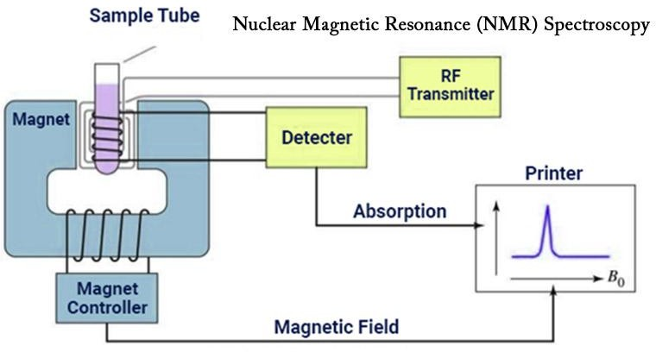

**Figure 2.4** NMR Spectrometer

### NEAR INFRARED SPECTROSCOPY (NIR)

**Near-infrared spectroscopy** (**NIRS**) [14] is a [spectroscopic](https://en.wikipedia.org/wiki/Spectroscopic) technique that uses the [near-](https://en.wikipedia.org/wiki/Near-infrared) [infrared](https://en.wikipedia.org/wiki/Near-infrared) region of the [electromagnetic spectrum](https://en.wikipedia.org/wiki/Electromagnetic_spectrum) (from 780 nm to 2500 nm). General applications of NIR are medical and physiological diagnostics and research including blood sugar, pulse oximetry, functional neuro imaging, sports medicine, elite sports training, ergonomics, rehabilitation, neonatal research, brain computer interface, urology (bladder contraction), and neurology (neurovascular coupling).There are also applications in other areas such as [pharmaceutical](https://en.wikipedia.org/wiki/Pharmaceutical) [15], food and agrochemical quality control, [atmospheric](https://en.wikipedia.org/wiki/Atmospheric_chemistry) [chemistry,](https://en.wikipedia.org/wiki/Atmospheric_chemistry) combustion research and astronomy.

This method is useful in finding the fake drugs based on the amount of frequency absorbed by the sample material. This method is similar to the Raman spectroscopy, except here NIR signals are used instead of a laser source. The Figure 2.5 shows us a typical NIR spectrometer. NIR signals are incident on sample and the reactions are observed in the detector and the fake materials are differentiated.

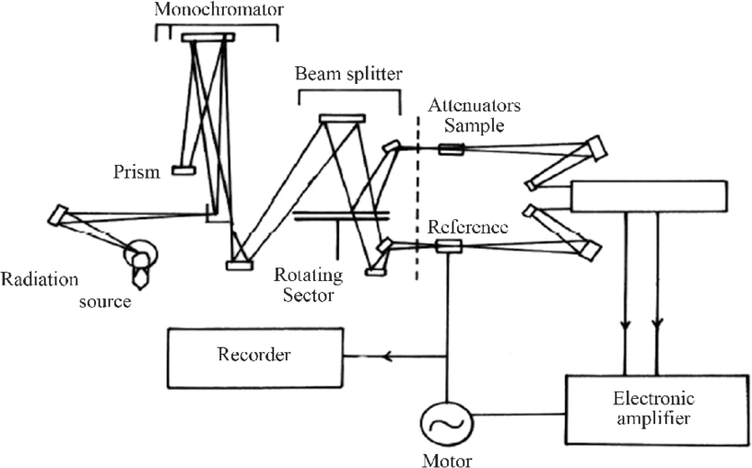

**Figure 2.5** NIR spectrometer

### THIN LAYER CHROMATOGRAPHY

Thin Layer Chromatography [16] is a technique used to isolate non-volatile mixtures. The process is conducted on a sheet of plastic, aluminium foil, or glass which is coated with a thin layer of adsorbent material. The material usually used is aluminium oxide, cellulose, or silica gel.On completion of the separation, each component appears as spots separated vertically. Each spot has a retention factor (*Rf*) expressed as (2.1):

dist .travelled by sample

*Rf* =

dist .travelled by solvent

, (2.1)

The factors affecting retardation factor are the solvent system, amount of material spotted, absorbent and temperature. TLC is one of the fastest, least expensive, simplest and easiest chromatography techniques. Like other chromatographic techniques, thin layer chromatography (TLC) depends on the separation principle. The separation relies on the relative affinity of compounds towards both the phases. The compounds in the mobile phase move over the surface of the stationary phase. The movement occurs in such a way that the compounds which have a higher affinity to the stationary phase move slowly while the other compounds travel fast. Therefore, the [separation of the mixture](https://byjus.com/chemistry/separation-of-mixtures/) is attained. On completion of the separation process, the individual components from the mixture appear as spots at respective levels on the plates. Their character and nature are identified by suitable detection techniques.

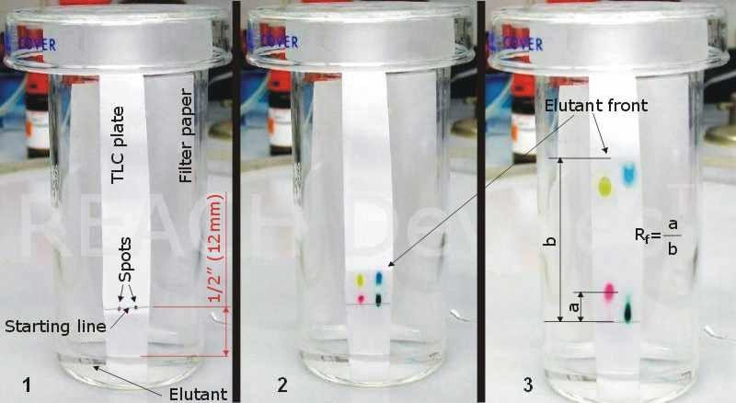

**Figure 2.6** Thin Layer Chromatography

The Figure 2.6 shows the process of thin layer chromatography. The sample to be tested is taken and prepared. The prepared sample is mixed with various solvents and run through a thin layer of paper. The chemicals present in the compound get separated at specific distance on paper. Based on the distance travelled by the chemical, its identity will be determined.

### NQR SPECTROSCOPY

**Nuclear Quadrupole Resonance** spectroscopy or NQR [17,18] is a [chemical](https://en.wikipedia.org/wiki/Chemical_analysis) [analysis](https://en.wikipedia.org/wiki/Chemical_analysis) technique similar to nuclear magnetic resonance ([NMR](https://en.wikipedia.org/wiki/Nuclear_magnetic_resonance)). Unlike NMR, NQR nuclear transitions can be observed in the absence of a [magnetic field,](https://en.wikipedia.org/wiki/Magnetic_field) and for this reason NQR spectroscopy is also called as as "[zero Field **NMR**](https://en.wikipedia.org/wiki/Zero_Field_NMR)." The NQR resonance is induced by the interaction of the [electric field](https://en.wikipedia.org/wiki/Electric_field) gradient (**EFG**) with the [quadrupole moment](https://en.wikipedia.org/wiki/Quadrupole_moment) of the nuclear [charge distribution](https://en.wikipedia.org/wiki/Charge_distribution). Unlike NMR, NQR is applicable only to solids and not liquids, because in liquids the quadrupole momentbecomes zero. Because the EFG at the location of a nucleus in a given substance is determined primarily by the [valence electrons](https://en.wikipedia.org/wiki/Valence_electrons) involved in the particular bond with other nearby nuclei, the NQR [frequency](https://en.wikipedia.org/wiki/Frequency) at which transitions occur is unique for a given substance. The Figure 2.6 shows a block diagram for NQR spectroscopy [19].

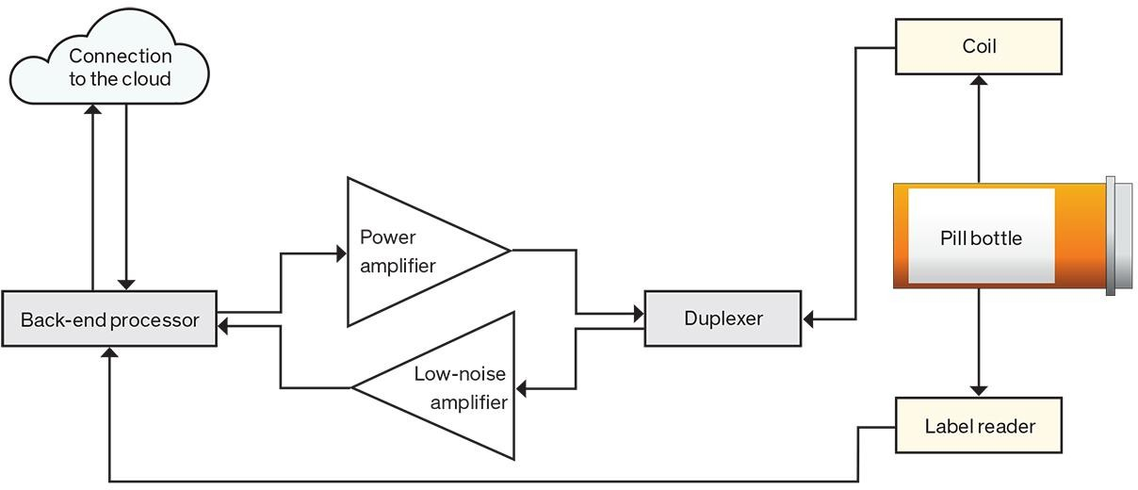

**Figure 2.7** Conceptual block diagram for NQR Spectrometer

A particular NQR frequency in a compound or crystal is proportional to the product of the nuclear quadrupole moment, a property of the nucleus, and the EFG in the neighbourhood of

the nucleus. It is this product which is termed the nuclear quadrupole coupling constant for a given isotope in a material and can be found in tables of known NQR transitions. In NMR, an analogous but not identical phenomenon is the coupling constant, which is also the result of an internuclear interaction between nuclei in the analyte.

#### LITERATURE SURVEY

A precise writing overview was led to look at the effect of fake medications on personal satisfaction and their outcomes unmistakably give proof that patients who purchase counterfeit meds have a low quality of Life as contrasted and everybody. As indicated by "World Health Organization (WHO)", fake and low quality meds implies that 250,000 kids a year are thought to kick the bucket in the wake of accepting trashy or through and through phony medications expected to treat intestinal sickness and pneumonia alone. The insights delivered by the association obviously show the above issue.

For each 10 medications, 1 medication is without a doubt adulterated. The individual and general wellbeing tolls are gigantic, similar to the financial weight — up to $200 billion yearly, everywhere throughout the globe. Low quality antimicrobials are regularly found in low-pay nations. Notwithstanding neglecting to treat disease, they additionally add to the advancement of antimicrobial opposition, which British scientists have assessed, could murder up to 10 million individuals every year by 2050. Be that as it may, fake prescriptions in practically every remedial class, from circulatory strain pills to medicines for malignancy and antibodies, are made and dispersed by deceitful crooks.

In nations with poor pharmaceutical control frameworks, such medications can be made in unlawful offices inside or outside the nation and enter the gracefully stream on the grounds that no exacting framework exists for review or endorsement. Costly systematic gear commonly isn't accessible, while basic, exact, and reasonable testing frameworks for use in the field, at drug stores, and at the purpose of care stay far off in for all intents and purposes every single poor nation. To exacerbate the situation, numerous nations don't have laws to characterize and uphold guidelines tending to violations identified with fake or unacceptable medications, nor do they have all around characterized legal activities once crooks are suspected or distinguished. In order find a fake medicine we need to find the chemical composition of the sample we have. It is not a simple process by any means. It requires chemists and a group of pharmacists to carefully examine the sample and one cannot examine

each and every tablet or sample they have. To overcome this problem we need to develop a device with which, even an illiterate can find if the medicine he/ she has is fake or not. The device must be of low cost and of high to above average accuracy. Hence, the concept of Nuclear Quadrupole Resonance is quite necessary and seems to be the solution for the present problem.

#### SUMMARY

This chapter emphasises on the detection of counterfeit drugs using different existing techniques such as FTIR, HPLC, Thin Layer Chromatography, Raman spectroscopy, and NMR spectroscopy. Previous methods are studied by conducting the literature survey. The concepts of Nuclear Quadrupole Resonance and the different methods developed for the proposed problem are discussed in the next chapter.

**CHAPTER III**

# NUCLEAR QUADRUPOLE RESONANCE

## NUCLEAR QUADRUPOLE RESONANCE

#### HISTORY

The NQR and NMR signal related researches dates back to the 1940s and 1950s [20]. Dehmelt and Kruger are laid the foundations of NMR signals for a solid using the signals from 35Cl in transdichloroethylene [21] [22].

Nuclear quadrupole resonance (NQR) uses the magnetic field generated in the radio waves which are further used to induce excitations in the solids. NMR refers to the process where the excitations in a material are induced by using an external static magnetic field whereas in the NQR the process involves excitations in the absence of magnetic field and the resultant interactions are solely due to the change in field gradient. In general, we can say that an NQR is same as NMR but the external static magnetic field will be zero.

Similar to the NMR spectroscopy, the main goal for NQR spectroscopy is to find out the relaxation times and nuclear transition frequencies (i.e., energies) and then to relate them with the properties of the material used. The property may be the sample temperature, for use as an NQR thermometer [23, 24], or even if the material used is fake or original [25]. The presence of the isotope with nuclear spin I > ½ must be present in the material for NQR spectroscopy to work, which is usually a highly available isotope.

The most common NMR isotopes, 1H, 13C, and 15N cannot be used since they have a nuclear spin I= ½ also, 12C and 16O cannot be used either as they have nuclear spin 0. Summing up in total, the isotopes which have nuclear spins greater than ½ can be used and remaining are not applicable and useless. Table 3.1 shows the spins, natural abundance, gyro- magnetic moment and charge. Some of these are present in almost every compound that can be available in medicines, cosmetics *etc.* The term γ/2π is called the gyro-magnetic moment and is an essential factor for NMR and NQR. This value decides the spin and properties of nucleus under magnetic fields. ‗*Q*‘ is the charge of the nucleus per cm2. The natural abundance here implies to the abundance of the isotope of that particular element with nuclear spins I >½.

**Table 3.1** Selected quadrupolar nuclei

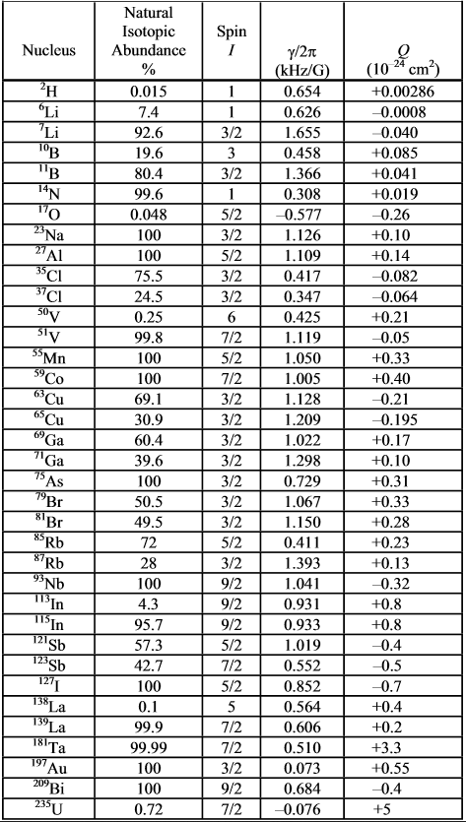

### INSTRUMENTATION

The process of NQR signal detection is same as for NMR signal detection. Hence, the design of the NQR spectrometers is similar to NMR spectrometers [26]. NQR spectroscopy does not require the large external static or dynamic magnetic field and its field control circuitry. A high speed spinning sample is necessary in the NMR whereas it is not at all necessary in NQR. As the magnetic field and spinning of the sample are not necessary, the RF signal power determines the size of the sample. Most of the NQR techniques involve in oscillators. Almost all these techniques are called as Continuous Wave techniques (CW). The LC resonant circuit determines the operating frequency and the sample are placed inside the inductor (L). The frequency is altered by changing the capacitance C, either electrically or mechanically. For NQR detection, the modern day computer controlled NMR spectrometers can be used. In these methods a separate frequency oscillator is used to determine the frequency and the sample is as usually placed in or near the inductor (L).

In almost all the NQR spectrometers, thermal noise is the principal source of electrical noise. In order to achieve better SNR values the quality factor must be maintained high so that the resistive losses are low. The SNR for NQR technique can be determined form the expression that can be used for NMR technique. There are several techniques for NQR detection and the most effective ones are mentioned below.

### CW SPECTROMETERS

Pound and Knight originated the use of a marginal oscillator for nuclear magnetic resonance [27]. Circuits with transistors and other semi-conductor elements are designed to detect the NQR signals. The marginal oscillator sustains low level oscillation with just enough feedback in the circuit. The energy is supplied by the active device up to the edge of its capacity almost its properties were lost from being linear. The level of oscillation changes significantly when additional energy is absorbed by the nuclei.

The transistorized version of the Robinson circuit [28] uses a special circuitry to maintain a fixed level of feedback value. The Robinson design is highly useful for scans over a wide range of frequencies. The super-regenerative spectrometer is actually a super- regenerative radio receiver but made to detect the induced EMF from the nuclei instead of receiving the signals from the distant radio stations. Insam demonstrated and gave a better explanation on how the super-regenerative spectrometers work [29]. In the super regenerative

circuit, the feedback condition is maintained and altered between two states, one state maintains oscillations and the other does not.

When changed from the non-swaying or "quenched" state to the oscillating state, the ideal time for the motions to develop to a foreordained level will rely upon the initial signal. That is, in the event that one observe an exponential development in voltage beginning at a time V (0) and with a period steady W, the time t to develop to a level V0 > V (0) can be expressed as a logarithm of above mentioned voltages.

Consequently, within the sight of noise and an induced EMF the oscillations will develop to the foreordained level sooner than with noise alone. The extinguishing signal might be created by isolated hardware or one can conFigure circuits which self-extinguish. Accurate line shapes with this spectrometer is not entirely possible due to the logarithm present in the equation. For the continuous wave (CW) techniques, and especially for powder samples, additional sensitivity is frequently made using a fixed external magnetic subject coils which might be switched on and off, combined with phase sensitive (―lock-in‖) detection. Usually 10–100 G fields are used at 10–100 Hz. At the point when the magnetic field is on (with any extremity), the NQR signal is expanded adequately so it is inconspicuous. Viably, the magnetic field on the other hand turns the NQR signal on and off and just the adjustments in the signal are recorded. Along these lines, all standard mistakes are expelled. Note that a similar technique is used for CW-NMR (usually with a sinusoidal magnetic field) resulting in a derivative signal. For NMR the magnetic field shifts the signal in frequency a bit rather than destroying it. As an alternative to an on/off magnetic field, the frequency of an NQR oscillator circuit can be modulated electronically using a varicap diode or similar device as part of the LC tuned circuit. With phase sensitive detection, one obtains a derivative signal (in the limit of small modulation) though often with significant baseline problems.

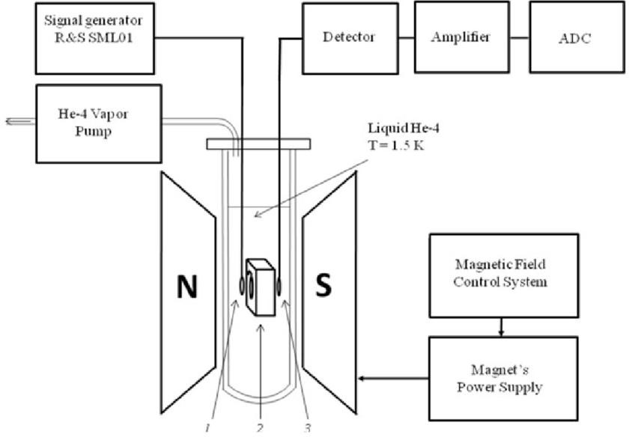

**Figure 3.1** CW NQR Spectrometer

The Figure 3.1 shows the block diagram of the Continuous Wave spectrometer and has been explained in the aforementioned paragraphs.

### PULSED SPECTROMETERS

The mechanism of pulsed NQR spectrometers is for all intents and purposes indistinguishable from that of expansive band NMR spectrometers aside from without an enormous magnet. Truth be told, many pulsed NQR spectrometers are likewise utilized (with a magnet) as wide band NMR spectrometers and the other way around. Since the pulsed strategy is substantially more adaptable than the CW procedures, most by far of present day NQR estimations are made utilizing pulsed strategies. A significant number of the pulse procedures started as NMR strategies and have been adjusted to the NQR condition. Since huge in-homogeneous expanding is normal in NQR, one of the most significant procedures is the utilization of spin- echoes, and related numerous multiple pulse methods, for the investigation of these widened lines. An essential PC controlled single channel pulse spectrometer is demonstrated schematically in Figure 3.2. Just like the case for NMR, the signals are frequently recorded in quadrature. That is, signals, which are in-phase (cosine-like) and 90° out of phase (sine-like) with a steady reference source, are all the while recorded in two channels. In the wake of

heterodyning and sifting, the recorded signs have a recurrence which is the distinction between that of the RF reference and that of the atomic polarization.

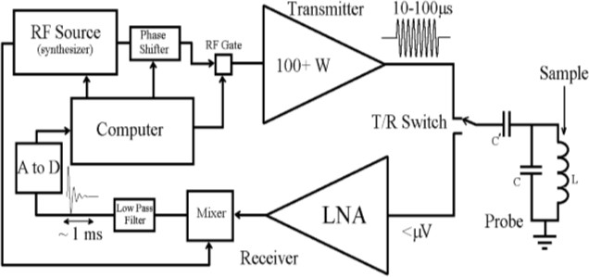

**Figure 3.2** Pulse Spectrometer

In numerous cutting edge spectrometers, the simple to advanced change is done before heterodyning, with the filtering and mixing performed carefully. The transmit/receive (T/R) switch demonstrated is typically actualized utilizing passive hardware. One regular circuit depends on the plan created by Low and Tarr [30], which utilizes semiconductor diodes and quarter frequency transmission lines. At frequencies underneath around 10 MHz, basic in NQR, the quarter frequency transmission lines are supplanted with lumped circuit reciprocals. Other tuned circuits utilizing diodes can likewise be utilized. While the Low Noise Amplifiers (LNAs) are shielded from harm by such a passive T/R circuit, the receiving circuit will be overdriven and there will be some "dead time" following the beat/ pulse while the receiver hardware recoups.

At lower frequencies this becomes worse by the ringing of the LC tuned circuit containing the sample. At the point when this ringing is a terrible enough, extra hardware can be added to reduce the oscillations, for example, a "Q-switch," or potentially one can switch the period of the applied RF beat by 180° for a brief time frame not long before the RF is killed. The last methodology can be very requesting on the powerful intensifier/ amplifier. The easiest pulse is the utilization of a solitary pulse with a length τp set to amplify the sign (1 to 100 Ps ordinarily). This is alluded to as a 90° or π/2 heartbeat in similarity to the NMR case; however the straightforward old style picture, this compares to a turn of the core by 90°,

isn't substantial. For powders, somewhat longer pulses (around 30% longer) are utilized, contrasted with solids, since a significant number of the crystallites don't have an exact ideal direction. After each pulse, some time-dependant signals will appear called as Free Induction Decay (FID). In the event that the spectral line shape is of intrigue, or in the uncommon case that there is more than one spectral line inside the excitation band width (~ 10 kHz) at that point the signal will be Fourier changed.

General spin echoes are regularly exceptionally valuable. The least difficult is a two pulse estimation here and there alluded to as the Hahn reverberation/echo with a 90° pulse, a period delay τ, a 180° pulse (double the length of a 90° pulse), trailed by procurement. The reverberation signal can be seen after a period *'τ'* after the subsequent pulse. Figure 3.3 delineates FID (one pulse) and basic reverberation (two pulses) signals utilizing one of the Br NQR changes of ZnBr2

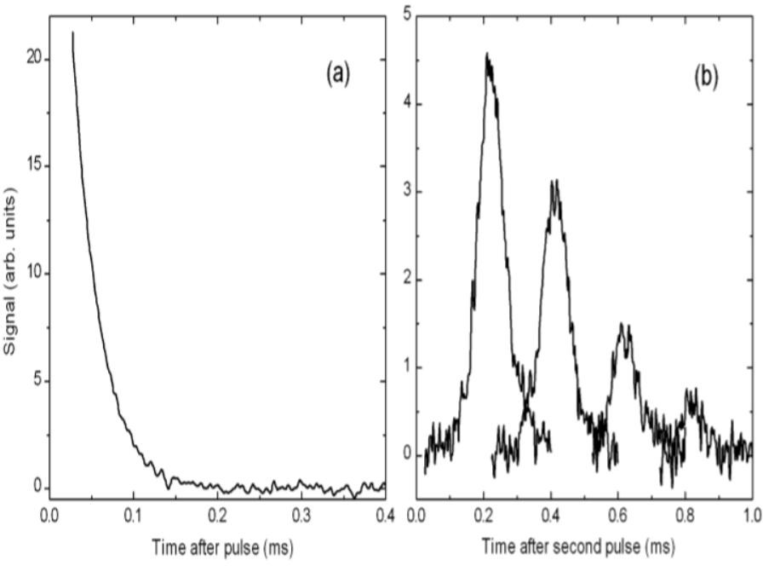

**Figure 3.3** Br NQR transmissions in ZnBr2

### Field Cycling NQR Spectrometers

Field cycling spectrometers are frequently used to improve the sensitivity, especially for low frequency NQR estimations, and furthermore in instances of low regular plenitude. There are a few unique kinds of field cycling estimations alluded to as NQR estimations – the most

normal are pulsed twofold reverberation methods where the real estimation is a NMR estimation.

In a field cycling spectrometer the example is then again exposed to a huge magnetic field and a little (or zero) magnetic field. Since huge magnetic fields are hard to turn on and off quickly, this is ordinarily accomplished by genuinely moving the example. Utilizing pneumatics, this can be routinely cultivated over a separation of around 1 m in around 100 ms or less.

In its most straight forward structure, the sample is put in an extremely high magnetic field to acquire a huge atomic parting and subsequently an enormous populace distinction. After balance is reached, the magnetic field is decreased and RF is applied at the NQR frequency, the magnetic field is applied again, and NMR estimation is performed. This technique can be applied to half-number spins straightforwardly or for any turn utilizing twofold reverberation. For the last mentioned, 1H is regularly utilized as the second core nucleus since it is handily watched utilizing NMR.

For twofold reverberation, one depends on "contact" between the two cores/ nuclei some time during the estimation. Contact here alludes to the situation where the atomic vitality level parting for the two cores coordinate and the cores are genuinely close enough with the goal that they can interact (e.g., by means of the atomic attractive dipole association). That match can happen either in the nearness or nonattendance of RF irradiation(s). When there is a match, there is proficient exchange of vitality between the two sorts of cores similarly there is transfer of vitality between two feebly coupled, indistinguishable pendulums.

In an elective structure helpful for chemicals that contain hydrogen, the enormous polarizations that can be accomplished for 1H in a magnetic field can be moved to a limited extent to the core to be estimated and afterward a conventional NQR estimation is made. While not as delicate, this method has the favourable position that an exceptionally uniform magnetic field isn't required for the NMR estimation. For instance, introductory presentation to the non-uniform magnetic field of perpetual magnets can be utilized to acquire an enormous and a non-uniform1H polarization, which would then be able to be moved to 14N before NQR estimation.

### Some less Common NQR Detection Schemes

The direct NQR methods referenced most importantly depend on Faraday's law of induction. Since the signal is created during the pace of progress of the magnetic flux, these procedures lose affectability at low frequencies. Interestingly, in a developing number of cases it is conceivable to recognize the magnetic flux straight forwardly, as opposed to its time subsidiary. At present, these elective detection techniques are hard to execute on a normal premise.

A superconducting quantum interference device, or SQUID, has a very low noise level and sensitive to the magnetic flux. For use as an NQR indicator, the time-subordinate atomic polarization is distinguished after a perturbation. Dissimilar to the NMR case, in any case, there is no static atomic polarization. NQR signals have been distinguished utilizing a SQUID at frequencies as low as small as few kHz up to around 1 MHz.

A second flux identification strategy as of late proposed for NQR uses an optical progress in a salt metal fume such that is exceptionally delicate to magnetic fields . It is fundamentally a type of optically recognized electron paramagnetic resonance (EPR) in an exceptionally feeble static magnetic field. For NQR discovery the time-dependant resonant magnetic field is provided by the precession of the close nuclear magnetic moments to be identified.

### SUMMARY

Nuclear Quadrupole Resonance is a standard phenomenon that can be observed in almost all the solid materials. The electrons around the nucleus will absorb the energy from the RF signals and undergo excitations and de- excitations. The additional amount of energy due to transitions will be released and we can detect it using the spectrometers. In the past days, as the technology is not transistorized and digitalized, this method is not considered viable for any detection or method. As we have better equipment and simulators, we can use this phenomenon and design a spectrometer which detects the NQR signals.

# CHAPTER- IV MATLAB- SIMULINK DESIGN

## MATLAB- SIMULINK DESIGN

### INTRODUCTION

The proposed design for the NQR spectrometer is based on the Pulsed NQR spectrometer. The design consists of four main parts they are: transmitter, receiver, NQR subsystem, and a measuring block. Each part will be discussed in the upcoming topics in detail.

The basic idea is to send the RF signals and incident them on to a drug sample. Then by the property of Nuclear Quadrupole Resonance, when the frequency generated from the RF source matches with the quadrupole resonance of the compounds present in the drug, then resonance occurs and NQR can be observed.

Here we have to notice that the NQR spectrum is unique for each material and acts like a chemical fingerprint. Hence from the above phenomenon, we get to know that the drug used is real or not by comparing the ideal sample‘s NQR spectrum with the test sample‘s spectrum.

The tool used to design the NQR spectrometer is MATLAB- simulink by Math Works. The physical devices or signals are simulated in the simulink considering the appropriate ambient conditions.

Pulse excitation of nuclear magnetic resonance (NMR) and nuclear quadrupole resonance (NQR) is widely used in solid state physics to study the internal electric and magnetic fields in crystals [31,32].

Pulsed NQR method based on the observation spins system response (induction signals or spin echo) on short and powerful pulses of radio frequency. The pulse Spectroscopy provides reducing the time observation of multi component spectra compared with continuous wave NQR excitation methods.

The need to improve the efficiency of weak NQR signals detecting initiates the development of computer models of nuclear quadrupole resonance that provide the possibility of determining the quality characteristics of NQR observation equipment.

The objective of this work is the study of signal conversions in pulse NQR observation method based on simulation modelling in order to develop more effective NQR spectrometer over existing analogues.

### NQR SIGNALMODEL

For computer modeling of signal conversions in pulse NQR spectrometer must first submit an expected response of nuclear systems for a short 6-pulse excitation. Most existing models of NQR signals own a large analytical cumbersome, which complicates their use in real-time systems modeling. The interaction of NQR spectrometer coil with a sample near the resonance frequency is sometimes represented as an equivalent electrical circuit that is not practical in modelling multiple spectrums in a wide frequency band [33].

More effective is the representation of the resonance system response at the RF excitation pulse as transient response, which is the free induction decay (FID) signal. After the excitement by radio frequency 90° pulses for the *kth* resonance frequency NQR signal has the form FID is given by (4.1) :

k

k

y(t) = ρ∑d

k=1

Kk e-[ β

+iω (T)]t + n(t), (4.1)

where *ρ* is total magnitude, the level of which is determined by excitation signal power; *Kk* – scale factor for the amplitude of *kth* component of resonance signal; *βk* – attenuation coefficient, depending on sample *T2*\* parameter; *ωk(T)* – NQR resonance frequency, depending on temperature *T; n(t)* – noise component of FID signal.

NQR spectrum obtained after Fourier-transform of the FID signal, described by (4.1). Pulsed method for studying spectral characteristics of NQR provides information about the dynamics of lattice and spin on measurement of relaxation times, what is the result of interaction within spin system (this process is characterized by the transverse relaxation time *T2*) and with other degrees of freedom in the lattice (this time the spin-lattice relaxation *T*1). After the action of the 180° excitation pulse, phase rotation of nuclear spins is reversed. As a result, after some time ‗*tg*‘ from the beginning of the experiment observed echo signal, which decreases with time under the law exp(-t/T2) [34]:

ym(t) = ρ∑d

k=1

Kk e-ηk(T)(t+m-2tg) e-βk|t-m.2tg+tg|+ iωk(T)t+ n(t) , (4.2)

Where ‗*ŋk(T)*‘ is the echo signal damping factor, depending on sample time T2; *tg* – the time interval between the first and second pulses; *2tg* – the time interval after the second pulse. Equation (4.2) represents a single echo segment, registered at excitation of the sample by *mth* 180° pulse.

### IMITATING MODEL OF NQR PULSED OBSERVATION METHOD

### Transmitter

Principles of apparatus to observe spin echo in NMR and NQR little different. To simulate the signal transformation in pulse NQR spectrometer, its imitating model in MATLAB Simulink software environment developed. The model includes a high-frequency transmitter (Figure 4.1), receiving channel (Figure 4.2), measurement unit (Figure 4.3), and is based on the classic single-coil coherent Fourier radio spectrometer scheme without converting the carrier frequency.

The source of the carrier frequency *C0* is the synthesizer (block-1), which generates oscillations in the 1- 50 MHz band. These oscillations are needed to fill the excitatory pulses in the NQR band resonance frequencies, and to form a reference signal for receiver quadrature detector. Oscillations from the output of the synthesizer comes to fast switch (block-3) forming excitatory pulses that are coherent with the phase of the carrier signal on the rise. Programmer (block-2) provides control of the switch that allows forming pulsed sequences of temporal correlations generated video pulses according to pre-set algorithm [35]

Output amplifier (block-6) with 50 dB gain, is loaded on the coil with the sample. The coil with a sample form NQR- subsystem (block-8) of the imitating model. As the developed model includes functional modules of different Simulink libraries, to convert of the data formats transferred between mathematical and physical devices used matching (block-4, block- 7, block- 9, block-11) and the configuration (block-5, block-10) blocks.

#### NQR Subsystem

In the case of resonance excitation by a single short pulse (pulsed NQR) the response signal describes the transient function (4.3).

s(t) = y(t) + ym (t) , (4.3)

and NQR-subsystem (block-8) in the proposed imitating model can be represented by a generalized transfer characteristic and mathematically given as (4.4).

H(p) = Y(p)/ X(p) , (4.4)

Where X(p)=L{x(t)} and Y(p)=L{s(t)} – images of the originals of the NQR excitation signal and of the NQR response signal by Laplace.

To study the samples, which is characterized by complicated multiplicity spectra (such as indium or gallium monoselenides) often used method of NQR [2]. In this case, in the NQR subsystem model should consider all components of the spectrum, representing signal response image in the form of (4.5).

Y(p) = Y1 (p) + Y2 (p) +... + Yn (p) , (4.5)

then transfer characteristic of NQR-subsystem will be given by the (4.6).

W(p) = ∑𝑛

𝑖=*0*

(𝐻𝑖(𝑝)) = Y1 (p) + Y2 (p) +... + Yn (p) , (4.6)

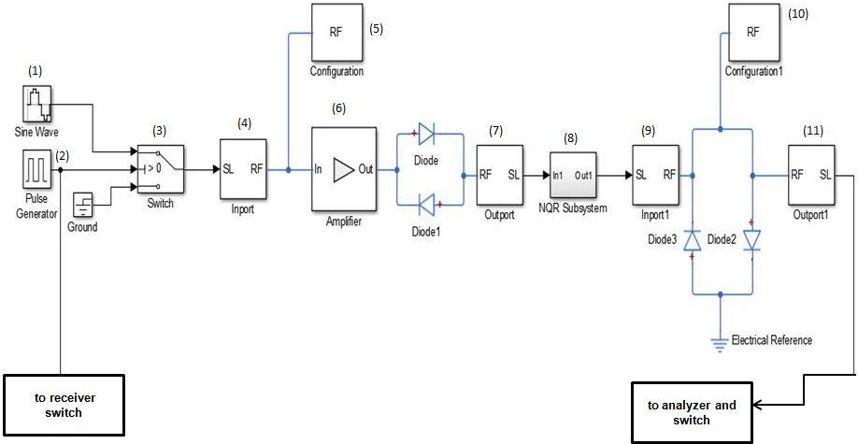X(p)

**Figure 4.1** High Frequency Transmitter.

### Receiver

Nuclear spin induction signal generated in the receiving coil goes to the electronic switch (block-12), which in practice is implemented as gate amplifier.

A low noise amplifier (block-14) to gain control range 0 dB to 50 dB plays a significant role in shaping the signal/noise ratio at the output of the spectrometer. To attenuate excessive noise and harmonics using a high pass filter (block-17), the cut-off frequency is set lower than resonant frequency NQR (1 MHz to 20 MHz). Selection of the filter pass band caused mainly by the spectral width of the resonance signal.

The quadrature detector is realized on the basis of two balanced mixers (block-19, block-20) with the same and phase- shifted by 90º reference frequencies (block-13, block- 15).

The first is set for the registration of a sinusoidal component of the NQR signal, and the second – a cosine component. In a real experiment, both detectors detect the mixture of the two orthogonal components. These signals represent the real and imaginary parts of the complex spectrum of NQR. To use the quadrature detector in a key mode are used comparators (block-16, block-18) which convert sinusoidal reference signal to square pulses. The result of multiplying the received signal *s(t)* which generally has a continuous spectrum *s(m)* for the reference signal with the frequency *m0* spectrum is transferred on the frequency axis by an amount equal to the reference signal frequency *m0*.

The signals from the quadrature detector through matching amplifiers (block-21, block-22) are transferred to the sixth order Butterworth low-pass filters (LPF) (block-23, block-24), which provide filtering of the desired signal from the double frequency component. So as the bandwidth of the detector is determined by low-pass filters cut-off frequencies, the effective value of the frequency range is caused by the width of the investigated spectrum and may vary in a frequency range 0 Hz - 500 kHz. The Figure 4.2 shows the receiver section of the simulation design of NQR spectrometer.

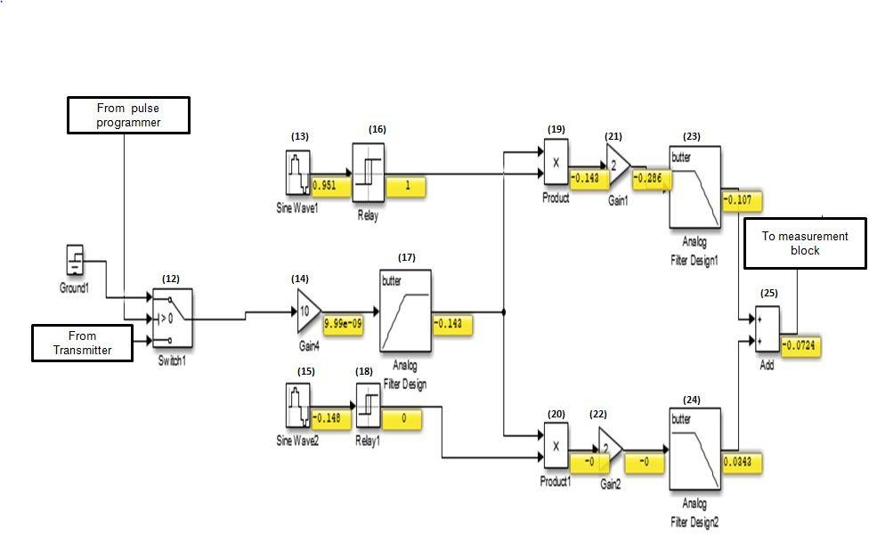

**Figure 4.2** Receiver

### MEASURING BLOCK

The measuring block of the NQR spectrometer consists of a gain, zero- order hold, and spectrum analyzers to analyse the graphs and outputs. Figure 4.3 shows us the measuring block of the proposed NQR spectrometer.

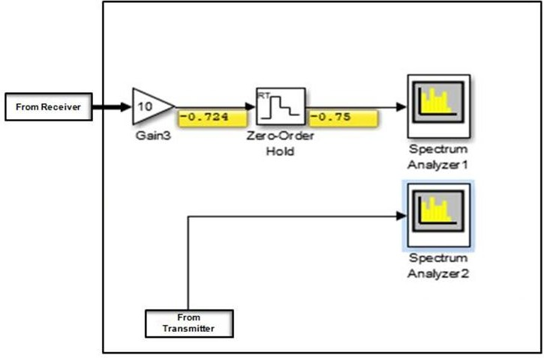

**Figure 4.3** Measuring Block

### DETECTION OF FAKE DRUG

By comparing the values of frequencies at which the resonance occurs when the sample is placed, we can find out if the drug is counterfeit or not. Each element has its own range of frequency at which they exhibit the nuclear quadrupole resonance. If the values do not falls into the expected range, there must be an illicit material in the drug or the composition is wrong. The Figure 4.4 shows us the compounds that contain nitrogen; including the drugs shown here, produce distinct NQR spectra with radio-frequency resonances [vertical bars] in the range of a few megahertz. Chlorine-containing compounds produce higher frequency resonances.

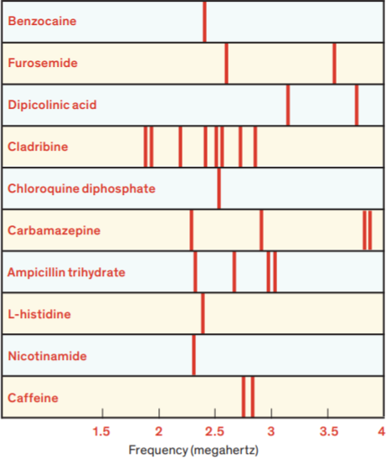

**Figure 4.4** NQR frequency spectra for various chemicals.

The Figure 4.5 shows us the expected outputs for indium NQR spectra at the end of transmitter or input of the receiver and Figure 4.6 shows the output of the receiver

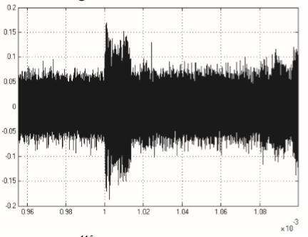

**Figure 4.5** FID signal at the input of receiver for Indium

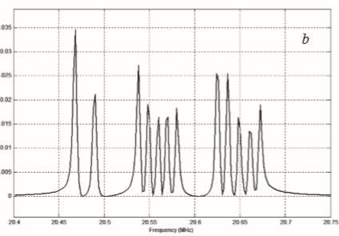

**Figure 4.6**FID signal at the output of receiver for Indium

### SUMMARY

The project mainly tries to identify the NQR spectrum of the material used with the help of the Transmitter, receiver, and the measuring block. The RF signals that are generated in block-1 of the transmitter are incident on the sample and the sample will resonate at the resonance frequency. The resultant signals will be filtered in the receiver and measured in the measuring block.

# CHAPTER - V SIMULATION RESULTS

## SIMULATION RESULTS

The present simulink design for the NQR spectrometer as mentioned in the previous chapters contains the transmitter, receiver and a measuring block. The signals from source are sine waves and when underwent through the transmitter the signals will be spread using a spectrum analyzer in the measuring block. The same signal will be sent to the receiver section where the quadrature detector filters the signal and we get to see the results.

For the simulation results of the signals transformation in pulsed NQR spectrometer validation, Indium is used. It is an element used in various medicines for cancer treatments. The NQR spectra of Indium will be observed and studied. The Table 5.1 gives the details of the signals that are responsible for initiating the generation of NQR signal. These can also be considered as the input signals. The input signal will be fed to the NQR subsystem. Then at the resonance frequency NQR signals will be emitted. Here we simulate the NQR signals and observe their properties.

**Table** 5.1 Inputs Parameters

|  |  |
| --- | --- |
| **Parameter/ signal** | **Value** |
| Simulated element | Indium |
| Input signal | Sine wave |
| Input Frequency | 20MHz |
| Input Amplitude | 1 volt |
| Sampling frequency | 50MHz |

The signals generated at the NQR subsystem will be fed to the receiver section. It contains a quadrature detector circuit. The main components used in the transmitter and the receiver and their parameters are included in the Table 5.2.

**Table 5.2** Main Components

|  |  |  |  |
| --- | --- | --- | --- |
| **Component** | **Type** | **Order** | **Cut-off values** |
| Diodes | Silicon | - | 0.6v |
| High pass filter | Butterworth | 8th | 15MHz |
| Low pass filter 1 | Butterworth | 6th | 1MHz |
| Low pass filter 2 | Butterworth | 6th | 1MHz |
| Amplifiers | Voltage | - | - |

The Tables 5.1 and 5.2 gives a detailed description of the signals and components used in the project. The NQR subsystem is the model designed from equations of NQR spectroscopy which is clearly explained in the previous chapters.

**Table 5.3** Outputs and their parameters

|  |  |  |
| --- | --- | --- |
| **Name** | **Parameter** | **Value** |
| NQR signal | Frequency(theoritical&  practical) | 3MHz/ 3MHz |
|  | Frequency range(theoritical) | 19- 21MHz |
|  | Frequency range (Practical) | 19-21 MHz |
|  | No.of.peaks (theoritical) | 12 |
|  | No.of.Peaks (Practical) | 11 |
|  | SNR (theoritical) | <20dB (10-20dB) |
|  | SNR (Practical) | < 20dB(10-20 dB) |

The Table 5.3 gives the details of the output signal and these are the values which would occur if the material used is Indium. The values are almost identical except with some distortion and peaks at uneven intervals but, the no.of peaks is same for both the theoritical and practical signals.

The simulated signals can be observed from the Figures 5.1, 5.2, 5.3, and 5.4.

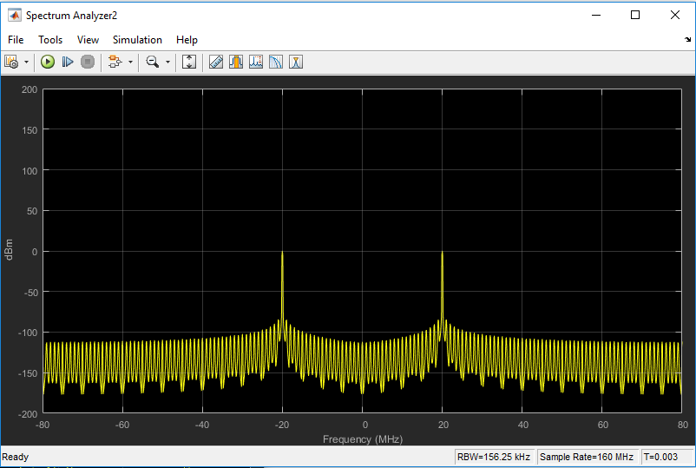

**Figure 5.1** Transmitter output at spectrum analyzer without NQR subsystem

It is to be understood that the output is not measured but rather simulated which imitates the NQR subsystem model for a sample drug. The source signal considered is 20 MHz; and it may be observed that two peaks are at the 20 MHz and this signal is further fed to the receiver section for a better output.

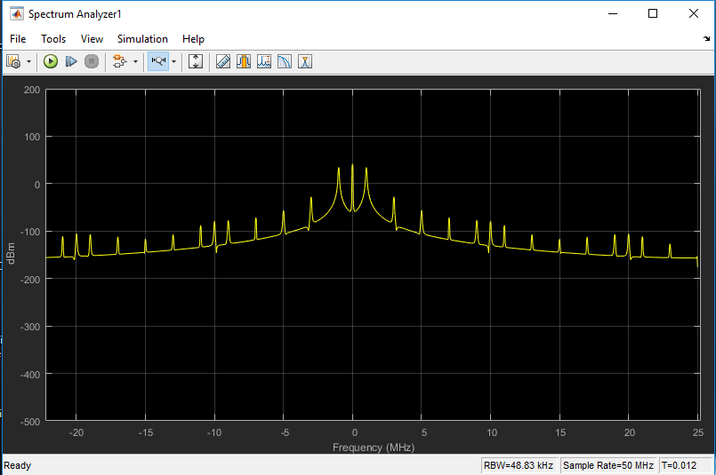

**Figure 5.**2 Receiver output for the 20 MHz signal without NQR subsystem

Figure 5.2 shows the output of the receiver without NQR subsystem. The signal we see here is a quadrature detected signal of the signal in Figure 5.1. The signal from the transmitter is fed to the receiver which has quadrature detector. The transformed signal after quadrature detection is observed in the spectrum analyzer. This is a pretty standard signal which is obtained for quadrature detector when fed with a sine signal. This helps us to know if the simulation design is working properly or not. Later, the NQR subsystem is introduced in the transmitter and the NQR signals are simulated. The Figure 5.3 and Figure 5.4 shows the simulation results of the transmitter and the receiver when the NQR subsystem is introduced.

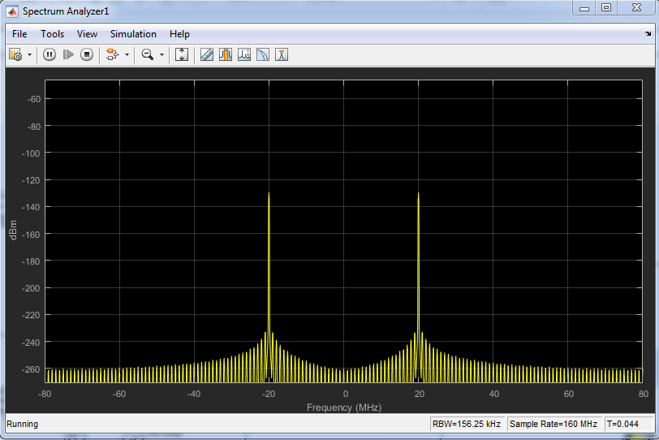

**Figure** 5.3 Transmitter output with NQR subsystem

When the NQR subsystem is introduced the output of the transmitter can be seen in the Figure 5.3. The peaks occur at 20MHz similar to the output without NQR subsystem. The peak width is about 3MHz. The significance of the width of peaks can be found in the output of the receiver which can be observed in the Figure 5.4.

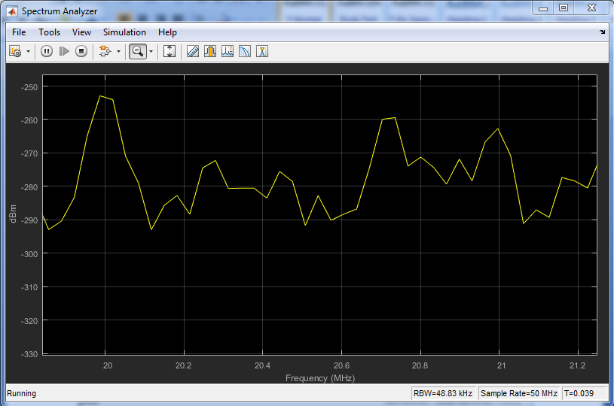

**Figure** 5.4 Receiver output with the NQR subsystem

The Figure 5.4 is the final output which is the output of the receiver. The NQR signal subsides in the range from 19 MHz to 21 MHz. In the Figure 5.3 we discussed about the 3MHz width of the peak. The same refers to the NQR resonance frequency for indium. When the signal from the transmitter is fed to receiver section, the signal is distributed. The peaks in the resultant signal indicate the energy released during the excitation and de-excitations of the atoms in the indium when incident with the radio signal (sine wave). The medicine can be detected as a fake when tested by the above process. The medicine we want to test will emit signals with its corresponding NQR frequency. Each element has a unique frequency range for resonant frequency. The resonant frequency will help us find if the medicine is a counterfeit or not. The frequency we got from the simulation can be compared with the theoretical values and determine the genuineness of the medicine. The properties of the NQR signal of indium can be observed in Table 5.3. However, the SNR is very sensitive. In the present simulation the SNR is very good at the beginning but gradually decreased with increase in simulation time. The SNR maintained for 50% of the time is in the range of 10- 20dB.

### 5.1 SUMMARY

A device can be made using the above simulation design with further modifications like providing protection from external radio signals and temperature. The signals are simulated in this project including the NQR signals. The objective of this project from this simulation is that Nuclear Quadrapole Resonance is a very reliable phenomenon that can be used to find out the genuineness in the medicine. Simulation is done to check the reliability of a design which can detect the NQR signals that are very weak in nature. The simulation includes the mathematical modelling of many signals which is a complex process. In simpler words, a simulation is complex compared to designing an actual hardware. However each method has some downsides. The simulation done here is missing the decay signals hence, the output is a bit distorted and SNR is decreasing gradually. These can be eliminated if it is implemented in hardware. Finally, in this chapter we simulated, observed and studied the properties of the NQR signals in the detection of fake medicines by simulating the main components and signals, and the outputs are verified with that of theoretical calculations and results.

# CHAPTER VI CONCLUSION

## CONCLUSION

Counterfeit drugs cause a huge loss to lives and health of several people. They result in around a quarter million deaths every year. Pharma crimes are increasing day by day. Common people can never find the difference between a fake drug and a real drug, unless a technician or a pharmacist guarantees that the drug is genuine. A technician is not available for everybody and at every time to check whether each drug is genuine or not. A thorough comparison and rechecking different fake drug detection methods, we came to a conclusion that NQR is a very good viable method at cheaper cost and less knowledge to find if the medicine is fake.

Various methods have been implemented but unfortunately none of them could be used by common people and surely needs expert supervision and thorough examination for detecting the fake medicine. The proposed NQR method has a World Health Organisation (WHO) score of 4 out of 8, even though it is in the starting stages of development. . The whole project is a simulink design, designed by using MATLAB®2016b. The NQR spectrum acts as a chemical fingerprint which will be highly useful in finding the fake drugs and fake materials like metals, non-metals etc. Until now the present method is used for finding explosives.

The receiver in the project is the key part as we get rough and clumsy image of signals by solely using the transmitter section which pretty typical way of detecting NQR signals. With the introduction of the receiver section we get a very clean output and significant improvement in the SNR.

The main drawback would be the distortion of the NQR signal due to the effects of Temperature and external FM signals from the radio and cell phone towers. The method can‘t find fake liquids as the net Nuclear Quadrupole Moment of liquids will become zero due to weak forces of attraction among the molecules and lack of rigidity. The problems due to signal interferences can be eliminated using an isolation device or an isolation box in which the experiment will be done

### FUTURE SCOPE

The same can be implemented using the hardware with RF signal generators, Range gates, LC coils and some signal processing software like MATLAB or LabVIEW etc. The implemented project will save a lot of time and can be used by a layman with a very basic understanding of the device.

The design can filter the NQR signals and improves the SNR unlike any other NQR detection method. The results also verified the same. Better results can be observed if the NQR subsystem is designed with precision and accuracy or we can directly implement the hardware using the simulink design made without any aid of NQR subsystem as it is only a replica to mimic the fake medicine.

# REFERENCES

### REFERENCES

1. Background Information on Counterfeit Drugs- <https://www.bayer.com/en/background-information-on-counterfeit-drugs.aspx>.
2. Countering the Problem of Falsified and Substandard Drugs <https://www.ncbi.nlm.nih.gov/books/NBK202524/>.
3. Technologies for Detecting Falsified and Substandard Drugs in Low and Middle-

Income Countries- https:/[/www.ncbi.nlm.nih.gov/pmc/articles/PMC3966738/](http://www.ncbi.nlm.nih.gov/pmc/articles/PMC3966738/)

1. World Health Organization (2012) Spurious/Falsely-labelled/falseified/counterfeit (SFFC) medicines. Available: [http://www.who.int/medicines/services/counterfeit/en/.](http://www.who.int/medicines/services/counterfeit/en/) Accessed 2013 Jul 25.
2. FDA's Anti-Counterfeit Device (2013). Available: [http://www.hhs.gov/open/initiatives/hhsinnovates/round6/fda-anti-counterfeit-](http://www.hhs.gov/open/initiatives/hhsinnovates/round6/fda-anti-counterfeit-device.html.%20Accessed%202013%20Jul%2025) [device.html. Accessed 2013 Jul 25](http://www.hhs.gov/open/initiatives/hhsinnovates/round6/fda-anti-counterfeit-device.html.%20Accessed%202013%20Jul%2025)
3. Deconinck E, Sacré P-Y, Courselle P, De Beer JO (2013) Chromatography in the Detection and Characterization of Illegal Pharmaceutical Preparations. J Chromatogr Sci 10.1093/chromsci/bmt006.
4. How an FTIR Spectrometer Operates - [https://chem.libretexts.org/Bookshelves/Physical_and_Theoretical_Chemistry_Textboo](https://chem.libretexts.org/Bookshelves/Physical_and_Theoretical_Chemistry_Textbook_Maps/Supplemental_Modules_(Physical_and_Theoretical_Chemistry)/Spectroscopy/Vibrational_Spectroscopy/Infrared_Spectroscopy/How_an_FTIR_Spectrometer_Operates) [k_Maps/Supplemental_Modules_(Physical_and_Theoretical_Chemistry)/Spectroscopy](https://chem.libretexts.org/Bookshelves/Physical_and_Theoretical_Chemistry_Textbook_Maps/Supplemental_Modules_(Physical_and_Theoretical_Chemistry)/Spectroscopy/Vibrational_Spectroscopy/Infrared_Spectroscopy/How_an_FTIR_Spectrometer_Operates)

[/Vibrational_Spectroscopy/Infrared_Spectroscopy/How_an_FTIR_Spectrometer_Oper](https://chem.libretexts.org/Bookshelves/Physical_and_Theoretical_Chemistry_Textbook_Maps/Supplemental_Modules_(Physical_and_Theoretical_Chemistry)/Spectroscopy/Vibrational_Spectroscopy/Infrared_Spectroscopy/How_an_FTIR_Spectrometer_Operates) [ates.](https://chem.libretexts.org/Bookshelves/Physical_and_Theoretical_Chemistry_Textbook_Maps/Supplemental_Modules_(Physical_and_Theoretical_Chemistry)/Spectroscopy/Vibrational_Spectroscopy/Infrared_Spectroscopy/How_an_FTIR_Spectrometer_Operates)

1. FOURIER TRANSFORM INFRARED SPECTROSCOPY (FTIR)- [https://www.mee-](https://www.mee-inc.com/hamm/fourier-transform-infrared-spectroscopy-ftir/) [inc.com/hamm/fourier-transform-infrared-spectroscopy-ftir/](https://www.mee-inc.com/hamm/fourier-transform-infrared-spectroscopy-ftir/) .
2. Andreas Synetos, Dimitris Tousoulis,. [Invasive Imaging Techniques](https://www.sciencedirect.com/science/article/pii/B9780128119082000180) in [Coronary](https://www.sciencedirect.com/book/9780128119082) [Artery Disease,](https://www.sciencedirect.com/book/9780128119082) 2018.
3. Raman Spectroscopy- [https://www.horiba.com/en_en/raman-imaging-and-](https://www.horiba.com/en_en/raman-imaging-and-spectroscopy/) [spectroscopy/](https://www.horiba.com/en_en/raman-imaging-and-spectroscopy/)
4. Raman Scattering- [https://www.sciencedirect.com/topics/medicine-and-](https://www.sciencedirect.com/topics/medicine-and-dentistry/raman-scattering) [dentistry/raman-scattering](https://www.sciencedirect.com/topics/medicine-and-dentistry/raman-scattering)
5. [R Martino](https://www.researchgate.net/scientific-contributions/67086376_R_Martino), [Myriam Malet-Martino](https://www.researchgate.net/profile/Myriam_Malet-Martino), [Véronique Gilard](https://www.researchgate.net/profile/Veronique_Gilard), [Stéphane Balayssac](https://www.researchgate.net/profile/Stephane_Balayssac). Counterfeit drugs: Analytical techniques for their identification, Literature Review in Analytical and Bioanalytical Chemistry 398(1):77-92 · May 2010.
6. [Andrei A Bunaciu,](https://www.researchgate.net/scientific-contributions/60009360_Andrei_A_Bunaciu) [Elena Gabriela UdriŞTioiu](https://www.researchgate.net/scientific-contributions/2002748783_Elena_Gabriela_UdriSTioiu), [Hassan Y. Aboul-Enein](https://www.researchgate.net/profile/Hassan_Aboul-Enein). X-Ray Diffraction: Instrumentation and Applications [Critical Reviews in Analytical](https://www.researchgate.net/journal/1547-6510_Critical_Reviews_in_Analytical_Chemistry) [Chemistry](https://www.researchgate.net/journal/1547-6510_Critical_Reviews_in_Analytical_Chemistry) 45(4) · April 2015.
7. NIR Spectroscopy- [https://www.sciencedirect.com/topics/chemistry/nir-spectroscopy.](https://www.sciencedirect.com/topics/chemistry/nir-spectroscopy)
8. Yang Huang,Marie-jia Gou,Kun Jiang,Lijun Wang,Guo Yin,Jue Wang,Ping Wang,Jiasheng Tu &Tiejie Wang. Recent quantitative research of near infrared spectroscopy in traditional Chinese medicine analysis; Pages 653-672.
9. Thin-Layer chromatography- [https://www.sciencedirect.com/topics/engineering/thin-](https://www.sciencedirect.com/topics/engineering/thin-layer-chromatography) [layer-chromatography.](https://www.sciencedirect.com/topics/engineering/thin-layer-chromatography)
10. Allen N. Garroway, Naval Research Laboratory. NUCLEAR QUADRUPOLE RESONANCE
11. A. N. Garroway, J. B. Miller, D. B. Zax, and M-Y. Liao, ―A Means for Detecting Explosives and Narcotics by Stochastic Nuclear Quadrupole Resonance (NQR),‖ U.S. Patent 5,608,321, March 4, 1997.
12. Bhunia S., and S. Mandal. Countering Counterfeit Drugs: A Technique used for Detecting Explosives Can Also Verify the Integrity of Medicines, IEEE Spectrum, pp. 39-43, Sep 2019.

[20] Pound, R.V. (1950) Phys. Rev. 79, 685-702.

1. Dehmelt, H.G. & Kruger, H. (1950) Naturwiss. 37, 111-112.
2. Das, T.P. & Hahn, E.L. (1958) Nuclear Quadrupole Resonance Spectroscopy, Supplement 1 of Solid State Physics, Seitz F. Turnbull D. (eds) (New York, Academic).
3. Ohte, A., Iwaoka, H., Mitsui, K., Sakurai, H. & Inaba, A. (1979) Metrologia15, 195- 199.
4. Huebner, M., Leib, J. & Eska, G. (1999) J. Low Temp. Phys. 114, 203-230.
5. Garroway, A.N., Buess, M.L., Miller, J.B., Suits, B.H., Hibbs, A.D., Barrall, G.A., Matthews, R. & Burnett, L.J. (2001) IEEE Trans. Geosci. Remote Sens. 39, 1108-1118.
6. Suits, B.H. (1994) in Trigg G. L. (ed.) Encyclopedia of Applied Physics, Vol. 9, 71-93.
7. Pound, R.V. & Knight, W.D. (1950) Rev. Sci. Instrum. 21, 219-225.
8. Robinson, FNH. (1982) J. Phys. E: Sci. Instrum. 15, 814-823.

[29] Insam, E. (2002) Electronics World 108(1792) 46-53.

1. Lowe, I.J. & Tarr, C.E. (1968) J. Phys. E: Sci. Instrum. 1, 320-322.
2. Bastow T.J., Cambell I.D., Whitfeld H.J., "A 69Ga, 115In NQR study of polytypes of GaS, GaSe and InSe," Sol. State Com., vol. 39, pp.307-311, 1981.
3. V. Khandozhko, N. Raranskii, V. Balazjuk, Z. Kovalyuk and A. Samila, "Temperature and baric dependence of nuclear quadruple resonance spectra in indium and gallium monoselenides," *Proceedings of SPIE*, vol. 9066, pp.90661G- 1-7, 2013
4. Michael D Harpen, "Analysis of the interaction between an MRI coil and a heterogeneous sample," *Phys. Med. Bid*., vol. 36, No 1, pp.133-141, 1991.
5. Zhang, Xinwang, "A low-power compact nuclear quadrupole resonance (NQR) based explosive detection system," in *El. Eng. Theses and Diss.*, University of Nebraska-Lincoln, 2014, Paper 58.
6. Yu. Bobalo, Z. Hotra, O. Hotra, L. Politans‘kyy, A. Samila, "Implementation of pulsed radiospectroscopy methods of NQR based on FPGA," *Metrol. Meas. Syst.*, vol. 22, Issue 3, pp.363-370, 2015.